**Command:** pwd

**Description:**

pwd stands for “Print working Directory”

‘pwd‘ - prints the current working directory or simply the directory user is, at present. It prints the current directory name with the complete path starting from root (/).

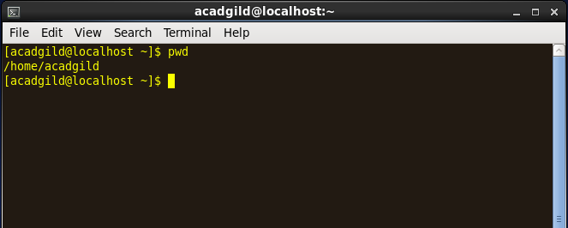

**Command:** VI

**Description:**

 If you specify an existing file then the editor would that file and can be edited. Else, it creates a new file

Creating a new file:

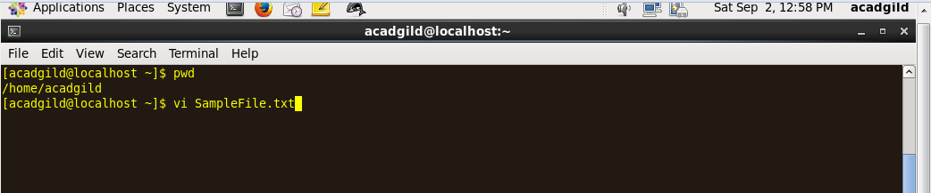

VI editor opens in the command mode:

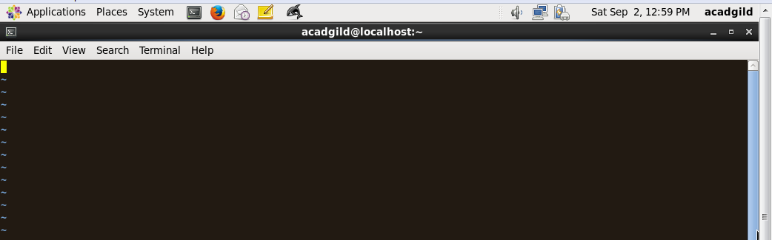

Press “i” to insert mode.

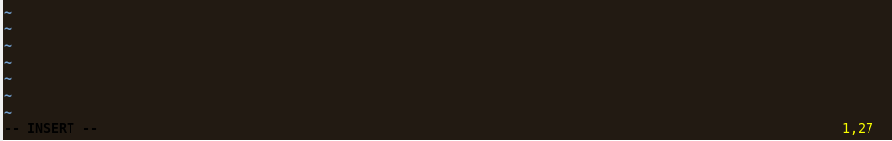

Enter the contents in the file

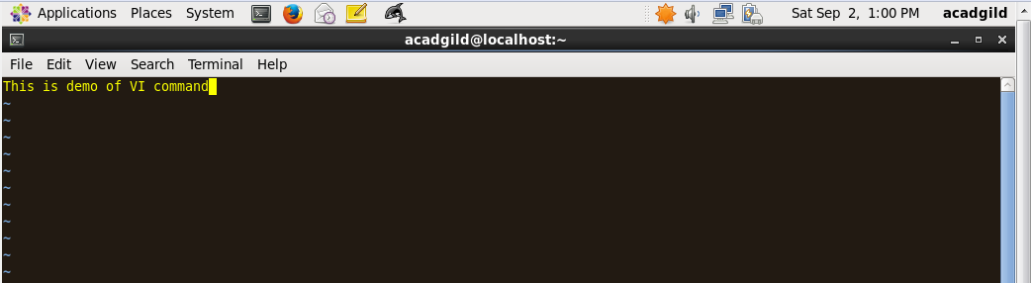

Press “Esc” to enter command mode . Press “:wq” to save and quit.



Check the content of the file

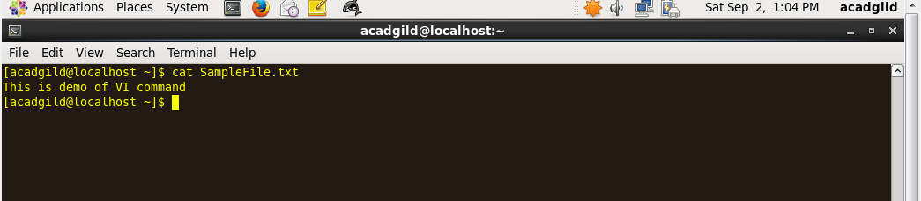

**Command:** Touch

**Description:**

The **touch command** is the easiest way to create new, empty files.

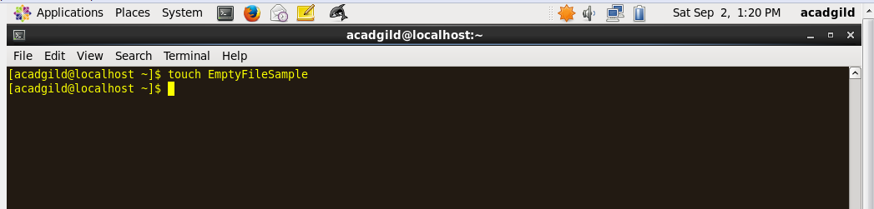

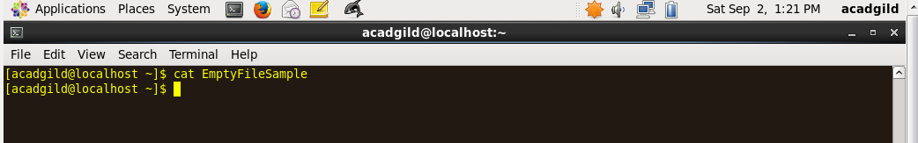

**Command:** **mkdir**

**Description:**

This command will create a subdirectory in your present working directory

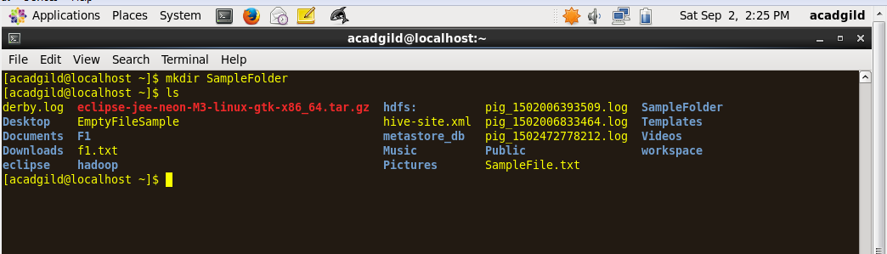

**Command:**: rm

**Description:**

rm [option(s)] file(s)

Removes the specified files from the file system. Directories are not removed by rm unless the option -r is used.

-r

Deletes any existing subdirectories

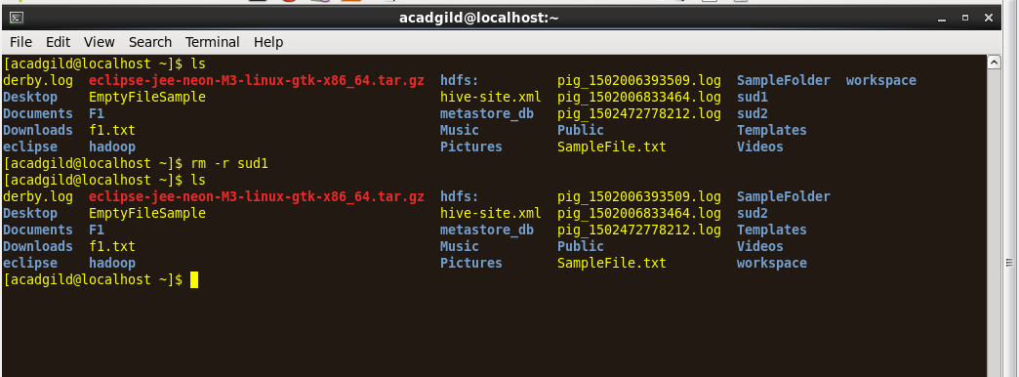

**Command:** ls

**Description:**

ls [option(s)] [file(s)]

If you run ls without any additional parameters, the program will list the contents of the current directory in short form.

-l

detailed list

-a

displays hidden files

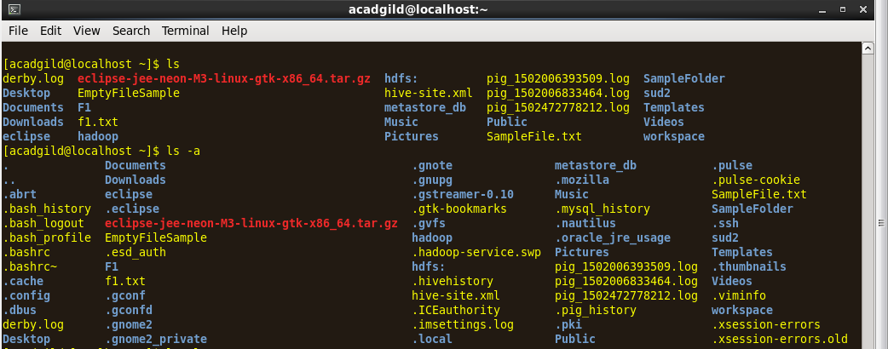

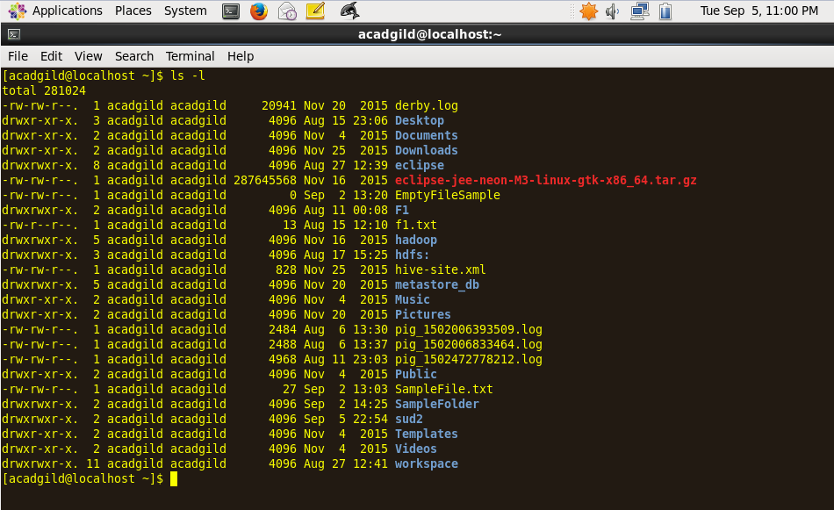

**Command:** echo

**Description:**

echo - display a line of text.

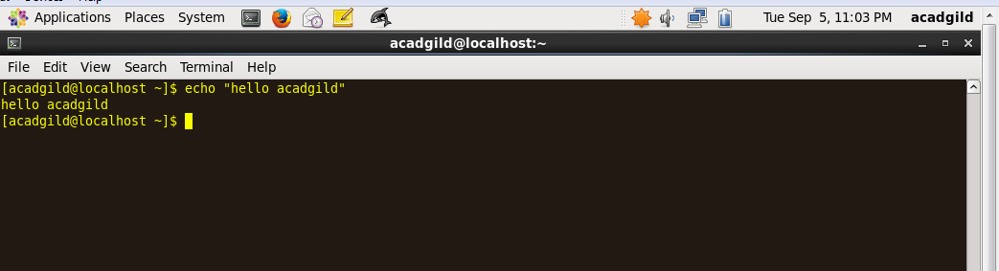

**Command:** cat

**Description:**

cat [option(s)] file(s)

The cat command displays the contents of a file, printing the entire contents to the screen without interruption.

-n

Numbers the output on the left margin

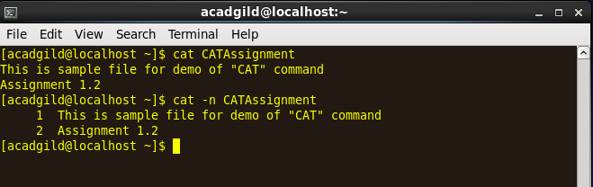

**Command:** who

Description: Lists who is logged on your machine

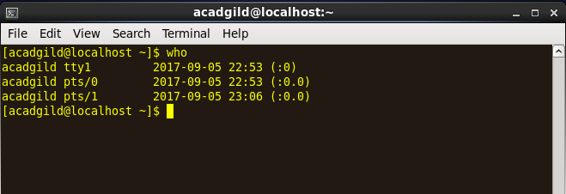

=====================================================================================

**Command:** cd

**Description:**

**cd** [options(s)] [directory]

Changes the current directory. **cd** without any parameters changes to the user's home directory.

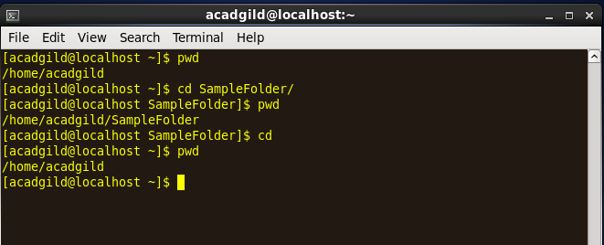

**Command:** date

**Description:**

Print out current date

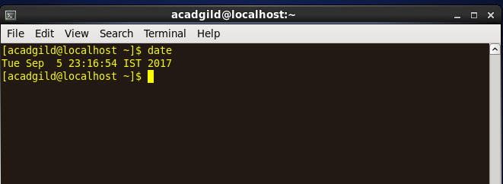

**Command:** cal

**Description:**

To display current month's calendar

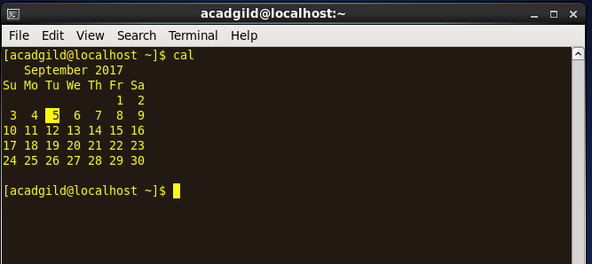

|  |  |  |
| --- | --- | --- |
| **cal <mo> <yr>** | cal 9 2000 | Print calendar for September 2000 |

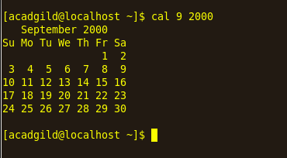

**Command:** mv

**Description:**

Move or rename files

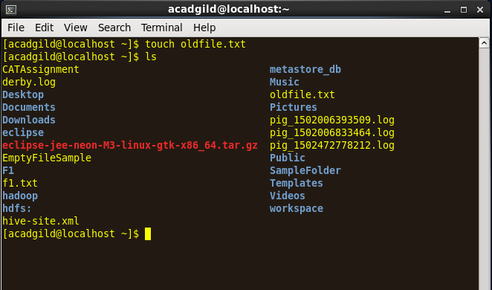

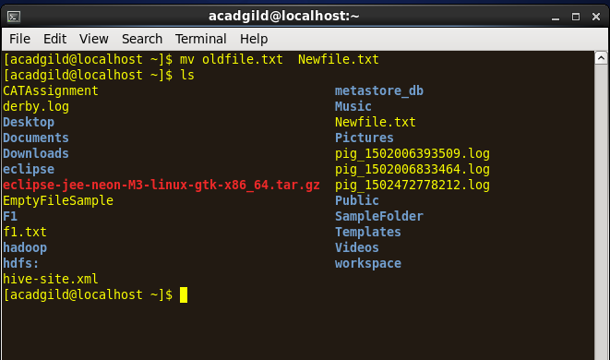

**Command:** cp

**Description:**

Copy file into directory  
Make backup of file

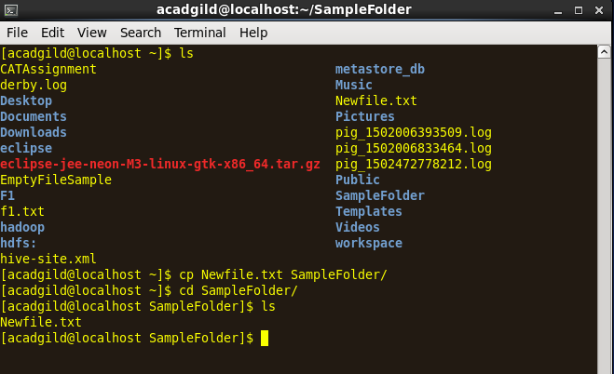

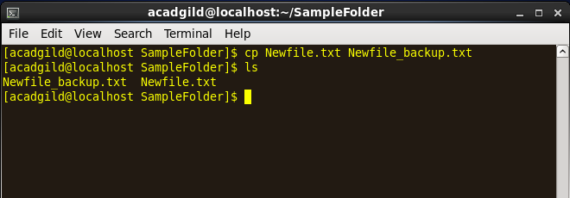

**Command:** which

Description:

which returns the [pathnames](https://www.computerhope.com/jargon/p/path.htm) of the [files](https://www.computerhope.com/jargon/f/file.htm) (or [links](https://www.computerhope.com/unix/link.htm)) which would be [executed](https://www.computerhope.com/jargon/e/execute.htm) in the current [environment](https://www.computerhope.com/jargon/e/environm.htm),

